Prospectus Document

Dale Froling and Michael Meyer

## 

**Links to Videos****0**

**Summary****1**

**Innovation****1**

**Benefits****2**

**Feasibility****3**

**Technologies****3**

Autonomous Drone 3

Alarm 4

Gas/Air quality sensors 4

Cameras 4

3D Mapping 6

Expandability 6

**Potential Market****7**

**Target Audience and Survey****8**

**Social Impact****9**

## Links to Videos

**Revised Pitch Video:**

<https://www.youtube.com/watch?v=CqVO2em6AB4>

**Technical Demonstration Video:**

<https://www.youtube.com/watch?v=ngatmUq0ZwM>

## Summary

The Emergency First Response Drone (EFRD) is a multi-purpose drone designed to handle and analyse natural disasters, search and rescue and other emergency situations. It is structured in a way that makes it modular to suit the purpose of the job such as its quad rotor system that can be interchanged with wings to extend flight time. Its ability to carry pre made equipment (such as first-aid kits) appropriate to the issue at hand will further improve its ability to cater to specific catastrophes. The drones presence will mitigate the risk emergency services need to take on a daily basis.

## Innovation

The primary innovation of the drone will be its versatility to adapt to a variety of situations. The previously mentioned flight system change is an example of making the drone last longer for search and rescue missions, in cases of people trapped in inaccessible locations, the drones carrying capability can drop supplies or medical supplies.

The EFRD’s cameras allow flexibility and grants it the ability to adapt to lots of different situations. Capable of night and thermal vision along with the standard camera, the drone will be able to pinpoint thermal signatures from a distance in search and rescue situations.

The drones cameras have a secondary function; mapping out the location. This map is made as the drone travels, be it through a building or over countryside. The drone will analyse points of interest with its sensors, marking off hazardous areas, toxic gasses and out of the ordinary heat signatures to pinpoint where people may be. This data can be used if human intervention is required, to provide insight to the emergency services of the potential hazards they may face.

## Benefits

The primary benefit of using a drone in emergency situations is the reduction of risk to emergency services personnel due to an increase in situational awareness. It enables an environment to be thoroughly assessed with potential hazards identified prior to risking human lives. If a building is on fire, collapsing or has a gas leak, it will be identified and communicated back to the ground station allowing personnel to be adequately prepared. A study conducted by the Embry-Riddle Aeronautical University concluded that “UAS’s [Unmanned Aerial System] can become an effective tool to increase situational awareness and support effective command and control.”[1]

Given the recent increase in the popularity of drones, the cost to build and maintain one has reduced over time. As such, drones are a very cost effective option as they are able to be built for a relatively low price whilst still maintaining the complexity and quality required for an EFRD.

In addition to the cost, drones are a desirable option as they can be easily and cheaply repaired in the field. Given the potentially hostile environments the EFRD may be operated in, the ability to efficiently service the drone will be of utmost importance.

The plethora of parts available and inherently DIY nature of drones means that they can be modified to suit particular needs. For example a search and rescue drone may need longer flight times and the ability to fly longer distances whereas an earthquake response drone may need to be more agile, allowing it to navigate inside buildings. Further, the drones modularity allows pieces to be repaired on-site, if the operator has the necessary skills.

## Feasibility

The limits of the drones feasibility rely on the access to the materials and parts accessible. Certain parts, such as the cameras and air quality sensors are easily acquirable, however the fireproof material that has previously been suitable for drone use is still in its stages of development, but the material itself (aramid fibres) has seen common use in automotive, aerospace and military industries.

Another issue comes from the 3D mapping. In current developments, the process of generating a 3D map based on the drones still images taken can take several hours, much too long for a time-sensitive operation. There are several factors to reduce the processing time, namely the rate of which images overlap and the power of the computer doing the processing, however nothing significant is currently available to speed it up.[2]

## Technologies

The technologies chosen have special consideration into the weight of the components. Given being a small type of drone, we have to closely monitor the weight of the drone so we don’t overburden it.

### Autonomous Drone

The drone will be capable of autonomously navigating itself through an area or building. This will be possible due to advanced flight control boards which utilise a range of sensors (i.e. GPS, proximity and altitude) enabling it to be aware of its surroundings. If the situation requires it, the drone will also be capable of being controlled manually which allows flexibility for the emergency services personnel.

### Alarm

To better alarm people within the vicinity of a coming threat, the drone will feature a compact alarm, using similar technology found inside personal alarms, albeit slightly larger. Personal alarms themselves are small and capable of emitting alarms of up to 140db and rather cost effective ($20)[3], but being attached to a high flying drone, a larger speaker may be necessary. The 130 - 140 decibel amount capable of these alarms is sufficiently loud, and is cited to be as loud as an ‘aircraft carrier deck’[4]

### Gas/Air quality sensors

These will be used to assess the quality of the air post-disaster. It can identify gas leaks, smoke and dust particles giving the emergency services team more clarity about the environment they will be entering. The size and weight of these devices is miniscule, and as such will be a valuable addition to the EFRD with little risk of being a burden.

### Cameras

The live camera feed will be used to undertake a preliminary assessment of the structural rigidity and general safety of the building or area. This technology currently exists for consumers, mainly in an analogue format however high definition digital options are becoming increasingly available.

The drone will also sport a thermal imaging camera (FLIR) and night vision to spot search and rescue victims with ease. The addition of a FLIR is primarily for simple fire and heat spotting. The image below represents just how well a fire is spotted. The square in the middle of the image also calculates the heat of the central location, however for ease of spotting a fire, it is tuned to only colour objects above 300 degrees fahrenheit (149 Celsius).

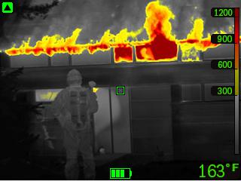

Source: <http://www.flir.com/assets/0/1272/1390/1392/6008/6009//8ceb3f1a-9303-4c0e-8940-8b14649ae001.jpg>

That’s not to say, however that FLIR devices are incapable of finding survivors of accidents. The same technology[5] is also used for spotting people and even water damage as well.

### 3D Mapping

3D mapping has become far more prevalent and advanced over recent years. Options exist currently for commercially available drones such as the Pix4D system. Project Tango is an indoor 3D mapping system which claims to be “driving a cost vs. capability curve for Indoor Mapping that is truly a game changer.”[6] By utilising 3 cameras it is able to effectively recreate indoor environments purely by moving through them. [This is an example of what is possible with this technology.](https://matterport.com/try-it/)

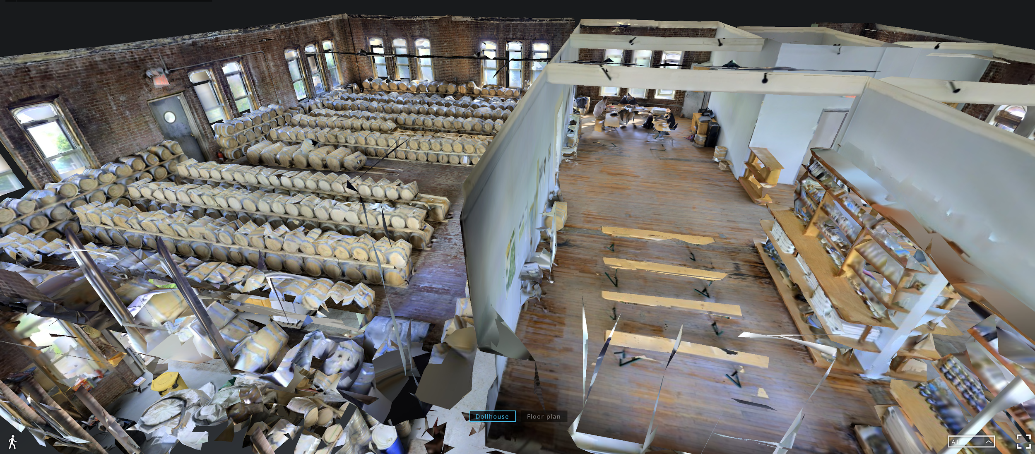

### Expandability

The drone’s central compartment allows for further expandability. It can accept a number of modules including microphone and speaker systems, more sensors and additional cameras. These modules can be easily installed by users. This is achieved by simply plugging them into the correct ports on the drone. Modules can be purchased after the initial purchase of the drone based on user needs.

## Potential Market

Due to the multi-purpose nature of the drone, emergency services departments around the world would have no trouble finding a use for the EFRD. Drone sales in general saw a growth of 63% in 2014 to 2015 alone[7], as well as an expected value growth of the industry from 3.3 billion in 2015 to 90 billion by 2025.

Emergency and military services have already begun experimenting with drones in their fields. Military drone use, more commonly referred to as UAVs (unmanned aerial vehicle) is one of the more well known markets, and has 7,494 unmanned drones in its US airfleet.[8]

Police have a broad range of uses for drones, to follow suspects, search and rescue, detecting marijuana growing fields and mapping crime scenes from the air.[9] The US border patrol flew 700 missions between 2010 and 2012 alone.[10]

The drone market in general has been steadily increasing exponentially given the miniaturisation and steady decline of cost of the technology. The graph below shows the large jump between 2013 and 2014, and the projected drone market from there is expected to reach under $100 billion. Another source[11] cites an expected ‘$127 billion by 2020.’ The drone industry is currently in a state of large growth.

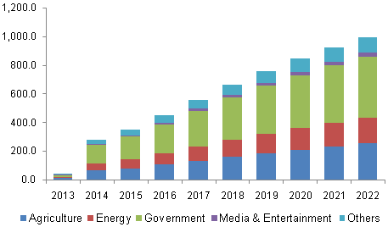

Source: www.grandviewresearch.com

## 

## Target Audience and Survey

The drones intended audience is emergency service crews around the world. As previously mentioned, it is designed to be versatile, and attract interest from the police force, fire departments and even perhaps paramedic teams. To interest these audiences, the drone will need to provide assistance that would be otherwise risky without the drone, and speed up time sensitive matters. The drones equipment and range of uses is sure to be appealing to emergency services that have previously faced situations that could have been more easily solved with the EFRD, and any equipment or innovations that save lives are sought after.

Following a survey, the majority of the 37 responses have average to minimal knowledge of drones, with only 10.8% (4 people) answering as having above average knowledge of drones. Despite the lack of background knowledge, the concept of the drone itself was met with positive reception, with 59% of respondents answering positively (4 and 5 out of 5) to the idea.

Several responses mentioned the desire to allow the drone to either emit an alarm or an operator's voice to inform people on the ground of an oncoming threat. A alarm component was chosen as the better suited device for a drone, as a high volume device is both cheaper and much smaller than a speaker. This will still appease the need to notify people of an oncoming threat from a large distance

## Social Impact

One of the more overwhelming responses to the market research survey was the issue of privacy. The drone itself would not store captured video, instead opting to stream the data and presenting a map rather than constant data. Due to the EFRD’s nature, it would need the camera to be always on to navigate so filming is unavoidable. The drones primary goal is to help rather than hinder and while there will always be cases of people not trusting the drone, it will adhere to all laws and legislations relating to use of drones and cameras in public areas.

Another concern of several respondents was of the drones security to hacking or physical attack. There are several noted cases, particularly of a $35,000 police drone being hackable due to security vulnerabilities[12]. The EFRD will be made with full attention security to stop any security threats, particularly to radio connection encryption to the assigned controller. The drones are made to be serviceable through updates through a computer if any backdoors are found.

1. <http://commons.erau.edu/cgi/viewcontent.cgi?article=1088&context=aircon>
2. <https://support.pix4d.com/hc/en-us/articles/204191535-Processing-Speed#gsc.tab=0>
3. <https://www.amazon.com/Vigilant-Wearable-Personal-Protection-PPS-23BL/dp/B007ZFQ8AY>
4. <https://www.chem.purdue.edu/chemsafety/Training/PPETrain/dblevels.htm>
5. <http://www.flir.com/suas/content/?id=74946>
6. <http://www.connexient.com/blog/entry/project-tango-and-3d-indoor-mapping-the-future-is-not-quite-now>
7. <http://expandedramblings.com/index.php/drone-statistics/>
8. <http://www.globalresearch.ca/unmanned-aerial-vehicles-uav-drones-for-military-and-civilian-use/5374666>
9. <http://people.howstuffworks.com/can-police-use-drones.htm>
10. <http://www.governing.com/news/headlines/Police-Agencies-Using-Border-Patrols-Drones-More-Often-Than-Thought.html>
11. <https://www.bloomberg.com/news/articles/2016-05-09/world-drone-market-seen-nearing-127-billion-in-2020-pwc-says>
12. <https://www.wired.com/2016/03/hacker-says-can-hijack-35k-police-drone-mile-away/>